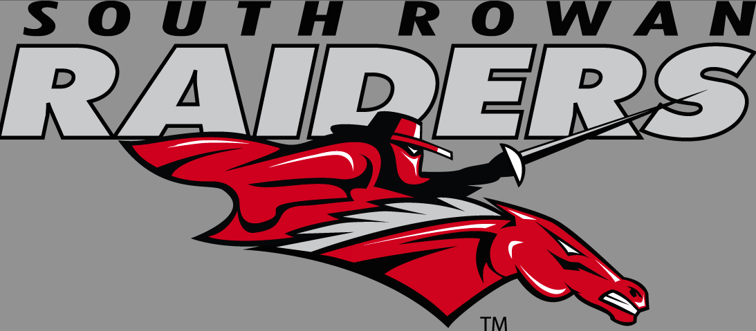 | SOUTH ROWAN HIGH SCHOOL
Honors US Turning Points
MR. Mullis (ROOM 211)
704-857-1161 (office)
mullisjj@rss.k12.nc.us (email)
www.mrmullis.weebly.com (website)

Course Description:

Honors Expectations: Honors US Turning Points is specifically designed for the highly self-motivated student. The curriculum is based on the North Carolina Department of Public Instruction, and is a prerequisite for Advanced Placement US History. The material is taught with greater complexity, novelty, acceleration, and reflects a differentiated curriculum than that of a standard level history class. Honors US Turning Points is distinguished by a difference in the quality of work expected and not merely an increase in quantity. An Honors Project is a requirement of this course.

Supplies Needed:
- Laptop (4) pens (blue or black ink only)
- Spiral Notebook (5) USB storage device
- Ear buds

Participation, Absences and Tardiness:
Participation in class discussion is a daily component of this course. If you are compelled to be absent from class, it is your responsibility to contact me regarding your absence and make up work. You have one day for each day missed to make up any assignments for a full credit grade. After this grace period expires, the late assignment policy becomes effective.

Your parent or guardian will be contacted after (2) unexcused late arrivals. After the (2) tardy parent notification, the SRHS tardy policy will be followed. (You are considered tardy if you are not in your seat at the sound of the bell)
Policy on Late Assignments: Assignments must be completed by their due dates to qualify for full credit. In-class assignments are due at the end of class. Out-of-class assignments must be turned in at the beginning of class on the next school day. Late work will only be accepted for two days beyond the due date of the assignment and twenty (10) points will be deducted from the assignment grade for each day that the assignment is late. Assignments missed because of an absence will be completed and turned in on the next day without any penalties. However, after this grace period expires, the late assignment policy becomes effective.

Academic Misconduct: Cheating and plagiarism will not be tolerated. Plagiarism is copying or using someone else's ideas and work and presenting them as your own, without giving proper credit. If caught cheating or plagiarizing, the matter will be addressed according to the disciplinary policies stated in your student handbook.

Classroom Procedures:
At the start of class
- Make sure you have your phones turned upside down and in the corner of table at beginning of class. We may use phones periodically. Your laptop is to be open and ready when bell rings for class
- Check my website for the day’s instructions and schedule.
- Be seated and begin working on assignments.
During class
- If you have a question or a statement, raise you hand and wait to be called upon before speaking.
- Quietly sharpen your pencil when needed. If someone is speaking to the entire class, wait until that person is done before sharpening your pencil.
- This is a “Social Studies” class. We will have lots of discussion. Please understand that everyone in the class is important. Everyone will have an opinion. Please understand that we will respect everyone’s opinion, even if you do not agree with what they are stating.
At the end of class
- When I announce that it is time to prepare for dismissal, make sure you save on your laptop.
- Gather your belongings and clean the area around your desk.
- Remain in your desk until the bell sounds. WE DO NOT STAND AT THE DOOR!
- Throw away any trash as you leave the room.
Grading
Quarter grades will be calculated as follows:

Unit Tests 20%
Quizzes 10%
Honors Project 25%
Participation, Homework, &Notebook 10%
Quarter Test 35%

The North Carolina Final Test grade will be calculated as 20% of the student’s final course grade.
Progress Reports:
Progress Reports will be sent home after 3 ½ weeks. Parents should review the progress report, sign it, and return it to the teacher. Progress reports count as a homework grade.

Grading Scale for SRHS
A | 93-100
B | 85-92
C | 77-84
D  F | 70-76  Below 70

